Car Fleet Management

|  |  |  |  |
| --- | --- | --- | --- |
| Venkatesh. K.1  *Professor, Department of CSE*  *NMIT*  *Bangalore, India*  krishnarao.venkatesh@yahoo.com | Prashant Shah2  *Department of CSE*  *NMIT*  *Bangalore, India*  shahprashant030@gmail.com | Ankit Prasad Gupta3  *Department of CSE*  *NMIT*  *Bangalore, India*  ankitgupta2069@gmail.com | Bivek Kumar Shah4  *Department of CSE*  *NMIT*  *Bangalore, India*  tricksterbivek@gmail.com |
| Sahib Ramnani5  *Department of CSE*  *NMIT*  *Bangalore, India*  ramnanisahib30@gmail.com | | | |

***Abstract—*With the increase in population, the use of vehicle is also increasing gradually. Some use public transport; some use personal vehicles and some take the vehicle on lease. There are some providers like Zoom Car, Ola, Uber, Bounce who provide vehicle for use on lease. However, these services have some trust issues with drivers leasing their vehicles. Some of the problems faced by the fleet managers are that the drivers drive rashly, steal parts of the vehicle and sometimes the vehicle itself, misbehave with the passengers etc., and as the name of the leasing company is prominently displayed on the vehicle they get a bad reputation in addition to financial loss..** **Car Fleet Management system has been designed to address these issues. The system relies on the use of Internet of Things (IoT) and Machine Learning technologies heavily to solve the identified problems. This project consists of seven modules: GPS Tracking; Geofencing; Vehicle Power Control On/Off; Drowsiness Detection; Ultrasonic Parking; Speed Monitoring; Automatic Wiper. GPS Tracking allows administrator to track the live location of the car. Geofencing allows the system to protect from the fraud if driver is trying to get away from the allotted area. Ultrasonic Parking feature assists the driver to park the vehicle without bumping into neighbouring objects. Speed monitoring allows administrator to view the speed of the car. and the Automatic Wiper helps driver by turning on when automatically rain droplets fall on the surface of the rain sensor. Also, as in the near future there will be more use of electric vehicles as compared to diesel/petrol vehicles we have incorporated a feature for remotely control the power supply of the vehicle. This also helps in ensuring that only authorized persons can operate the vehicle. As the IOT platform has been integrated into the vehicle the real-time status of the vehicle can be gathered and transferred to the fleet manager and displayed on a dashboard. Hence, the fleet manager can get the status of all the vehicles in his fleet all the time which will help in better managing the fleet.**

***Keywords*—Car Fleet Management, Internet of Things, Machine Learning,**

I. INTRODUCTION

Fleet Management is the process in which fleet and asset information is managed in proper way by which it enables the company to reduce the cost, improve efficiency and ensure compliance across an entire fleet operation. [6]

Car Fleet Management (CFM) allows any organization like Zoom Car, Ola, Uber to monitor the condition of the vehicle and manage it in a proper way. Like the existing Truck Fleet Management system this will provide beneficial result to the car leasing organizations. It also has some additional features relevant to car fleet management.

Rapid advance and adoption of technologies associated with Internet of Things has resulted in the availability of sophisticated miniaturized sensors and processing elements available for the Automotive platform also. The CFM system is built using the IOT platform. In addition, some of the features like information on driving habits of specific drivers, eye blinking patterns among others can benefit from the use of Machine Learning algorithms to detect unusual behaviour patterns and provide warnings for suitable corrective measures to be implemented.

II. LITERATURE SURVEY

Car Fleet Management is one of the IoT based project which allows organization like Zoom car, Ola, Uber to monitor their leased vehicle in proper way. Fleet Management System include different parameters like GPS tracking, Geofencing, Fuel level indicator, speed monitoring, etc. As an existing system, paper [1] basically deals only with Intelligent Transportation System (ITS) which provide some features like GPS tracking, NFC payment, etc. on transportation vehicle. Whereas paper [2] is totally based on fleet management system which provide only fuel level monitoring and GPS tracking. Apart from this paper [3] has introduced some new features of GUI interface and Linux based embedded microprocessor. Paper [4] just talked about the drowsiness detection where author have proposed one algorithm which alert driver when driver is about to sleep. Paper [5] is basically based on road accident. It provides the method how the road accident can be decreased.

III. OBJECTIVES

The objectives of this system are:

* Track live location of the car and checks if he/she cross the boundary of geofenced area.
* Turn on/off the main power supply of the car.
* Monitor the behavior of the driver by detecting drowsiness.
* Monitor speed of the car and automate the wiper.
* Park the car very efficiently without any collision.
* Build the system by which above mentioned things are possible to implement and provide the best result for the car leasing company like Zoom car, Ola, Uber.

IV. SYSTEM DESIGN

CFM system is designed using IoT and ML technologies. Dashboard application software at the central office consists of a backend developed using the Firebase Real time database and JavaScript, and the front end is developed using HTML, CSS, JavaScript, Bootstrap. Where in the hardware side, different sensors, Raspberry pi, node MCU, Arduino are used.

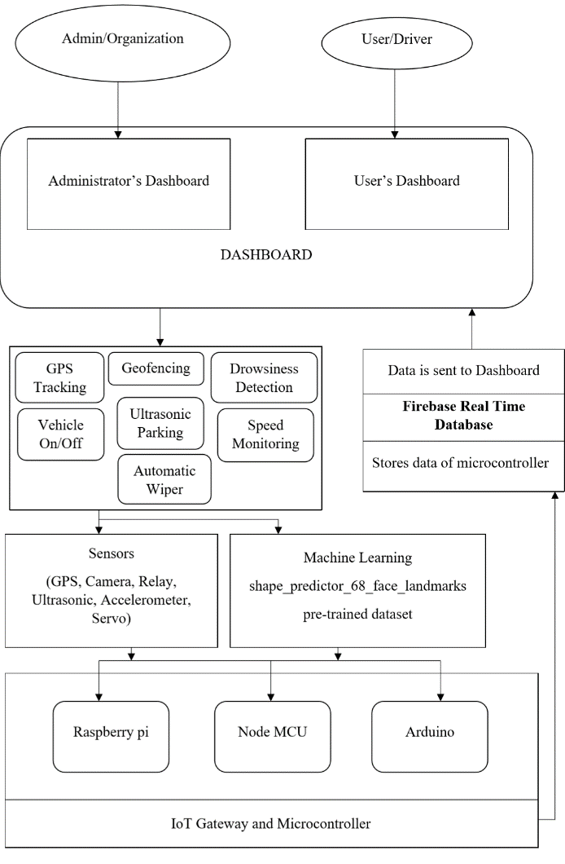

Fig 1: System Architecture

V. THE PROPOSED SYSTEM

The system is prepared for the company like Zoom Car, Ola, Uber, etc. which provides services of car to public as a lease. And with this there is high chance of damage of the vehicle part in a developing country like India. So, this system based on Internet of Things and Machine Learning is prepared to help those company to monitor all the vehicle taken on lease. CFM consists of seven modules:

*A. GPS Tracking*

Live location of the driver can be visible in the dashboard using GPS Tracking. This system uses Node MCU and GPS module to fetch the live location of the vehicle taken on lease and displays to administrator he/she can easily monitor the live location of the vehicle in the real time basis.

*B. Geofencing*

Geofencing uses GPS to define the geographical boundaries. It allows administrator to set up triggers for the vehicle so when vehicle enters/exits the boundaries an alert message is generated and sent to the administrator.

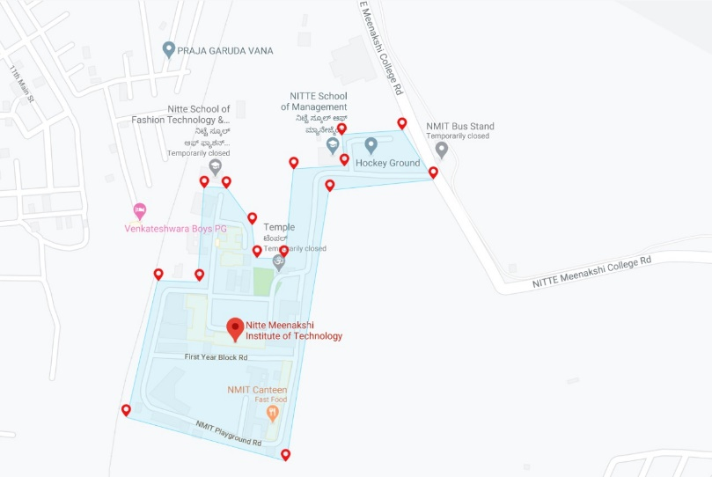

Fig 2: Geofencing Boundaries in Google Map

This system uses Google Map API to fence the geographical boundaries and show it on dashboard. When the GPS location of the vehicle goes outside the boundaries then it notifies the administrator.

*C. Vehicle Power Control ON/OFF*

This system allows administrator to turn on/off the main power supply of an electric vehicle remotely. If the vehicle is parked in any remote location, then there is high chance of the vehicle being stolen. So, the control of the main power supply of an electrical vehicle can be handled directly by the administrator.

Relay sensor is used to switch on/off the main power supply. Remotely turning on/off doesn’t mean that without administrator driver can’t stop the vehicle. Starting/Stopping of the vehicle is fully done by driver. But just the main power supply which provide electricity to the vehicle is monitored by the administrator. Here before driver starts the vehicle, he/she needs to take permission from the administrator to turn on the main power supply. And after turning on the main power supply driver can start the vehicle. After ending the trip driver needs to inform the administrator the end of the trip and administrator will turn off the main power supply.

*D. Drowsiness Detection*

There might be situation where driver can get sleepy during the ride which can lead to accident. Such drowsiness can be detected using this system. This system will detect if the driver closes eyes for more than five seconds.

This system uses Machine Learning to fetch the EAR (Eye Accept Ratio) and alert driver if he/she closes eyes for more than 5 seconds. It will be annoying if the alarm keeps buzzing every time the driver blinks the eye.

*E. Ultrasonic Parking*

It is sometimes very difficult to view all objects behind the car using only the rear-view mirror while parking. So, Ultrasonic Parking can be very useful in such cases. This system uses Ultrasonic sensor which works on the principle of reflection of wave. Ultrasonic wave is transmitted by sensor which travels in air and when it gets obstructed by any material it gets reflected. The reflected wave is captured by the ultrasonic receiver module. Distance can be calculated by using the formula:

$Distance=Speed×Time$ [7]

If distance is less than a prefixed threshold then the driver will be alerted that there is a likelihood of collision with an obstacle. This will help in preventing damage to the vehicle while parking.

*F. Speed Monitoring*

Most of the accident nowadays occur due to over speed in India. Car Fleet Management allows the organization to monitor the current location as well as the speed of the vehicle on the administrator’s dashboard. If the speed of the car crosses the predefined limit then the driver will be alerted by the administrator. This can be implemented using accelerometer sensor. Using Raspberry pi and accelerometer sensor we can calculate the speed of the vehicle and display the speed on the dashboard of administrator.

*G. Automatic Wiper*

Automatic Wiper can be one of the best examples of automatic vehicle component. This system helps driver not to worry much about the wiper switch. Whenever rain droplets fall on the rain sensor, servo motor will start rotating with an angle of 90°. By this the wiper will also turn on automatically.

VI. METHODOLOGY

Seven modules of CFM consist of different sensors. Sensors send the data to the IoT gateway. Here, microcontroller process the data of sensor and send it to the Firebase Realtime Database. Firebase Realtime database provide the storage functionality where the data is stored. Finally, the firebase sends the result in the form of data to the dashboard. Dashboard represent the valuable data and provide the result to the user and administrator.

Fig 3: Dataflow of Car Fleet Management

In the dashboard, administrator can view and monitor every parameter whereas driver can just view the parameters. Also, they can contact to each other in the case of need.

VII. RESULT

With successful implementation, it is able to achieve the following output.

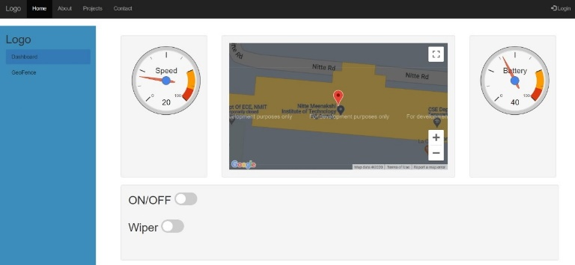

Fig 4: Screenshot showing main dashboard

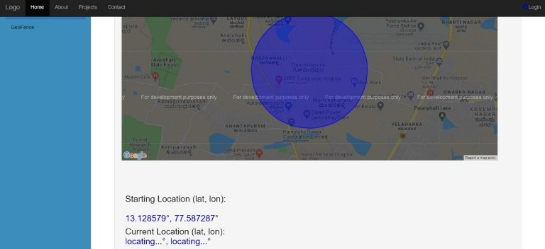

Fig 5: Screenshot showing geofencing monitoring

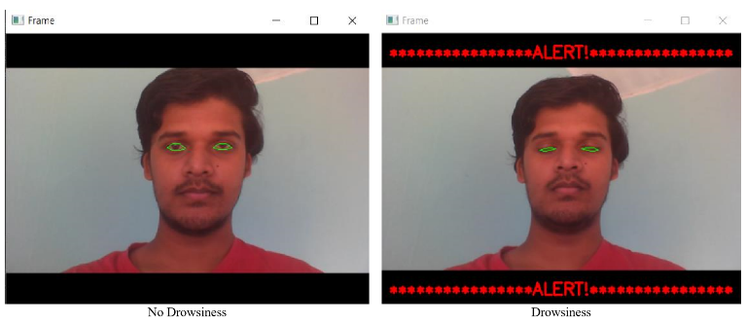

Fig 6: Drowsiness Detection Output

VIII. CONCLUSION

This project aims to target the companies like Zoom car where they will be able to track and monitor their vehicle in real time and help to reduce the cost for maintenance since the vehicle information can be visible using IoT in the dashboard.

It will reduce the work of the fleet manager to a great extent as all activities are digitalized and automated. Every sensor acquires different type of data and sends it to the monitoring system. In monitoring system Firebase stores the data and the microcontroller processes all the data and again stores it in the firebase. After processing all the data, the information is visualized in the dashboard. Dashboard displays GPS location of the vehicle, Geofencing, Driver Drowsiness, Vehicle Power Control ON/OFF status, Wiper status. It just needs some manager to stay at backend and monitor the status of the vehicle. With the successful implementation of this system it can prove highly advantageous to organization. Regular update on the system after implementation can upgrade this proposed system and can be one of the best Car Feet Management System in future.

REFERENCES

1. Thiyagarajan Manihatty Bojan, Umamaheswaran Raman Kumar, and Viswanathan Manihatty Bojan, “An Internet of Things based Intelligent Transportation System”, 2014 IEEE International Conference on Vehicular Electronics and Safety (ICVES), December 16-17, 2014. Hyderabad, India [Available: IEEE Explore Org]
2. Mahaveer Penna, Shivashankar, B Arjun, K R Goutham, Lohith N Madhaw, Kumar G Sanjay, “Smart fleet monitoring system using Internet of Things (IoT)”, 2017 2nd IEEE International Conference on Recent Trends in Electronics, Information & Communication Technology (RTEICT), 19-20 May 2017, Bangalore, India [Available: IEEE Explore Org]
3. Channakeshava Gowda V R, Gopalakrishna K, “Real Time Vehicle Fleet Management and Security System”, 2015 IEEE Recent Advances in Intelligent Computational Systems (RAICS), 10-12 December 2015, Trivandrum [Available: IEEE Explore Org]
4. Challa Yashwanth and Jyoti Singh Kirar, “Driver’s Drowsiness Detection”, 2019 IEEE Region 10 Conference (TENCON), Year 2019, Hyatt Kochi Bolgatti, Kerela, India [Available: IEEE Explore Org]
5. R. Srinivasan, A. Sharmili, Dr. S. Saravanan, D. Jayaprakash, “Smart Vehicles with Everything”, 2016 2nd International Conference on Contemporary Computing and Informatics (IC3I), Year 2016, Salem, India [Available: IEEE Explore Org]
6. Sarah Wilkinson, “Everything you need to know about Fleet Management” chevinfleet.com, para. 1, Sep. 25, 2018. [Online]. Available: https://www.chevinfleet.com/au/news/what-is-fleet-management-software. [Accessed Feb. 12, 2020].
7. “HC-SR04 Ultrasonic Sensor” components101.com, para. 1 to 5, Sep. 18, 2017. [Online]. Available: https://components101.com/ultrasonic-sensor-working-pinout-datasheet. [Accessed Mar. 20, 2020].